**Programming Fundamentals**

**Lab Report**

**Lab 13**



|  |  |
| --- | --- |
| Group Members Name & Reg #: | **Muhammad Haris Irfan**  **(FA18-BCE-090)** |
|  |  |
| Class | Programming Fundamentals CSC103 (**BCE-2B**) |
| Instructor’s Name | Dilshad Sabir |

**In Lab Tasks**

**Question no: 1**

Write a C program that initialize a structure called “mobile”. Instance of that object should contain fields vendor i.e. Huawei, Samsung or Nokia, owner name and its IMIE (International Mobile Equipment Identity) number. User should enter the minimum of two records. And print these records using pointers.

**Solution:**

The Code for the following code is attached below,

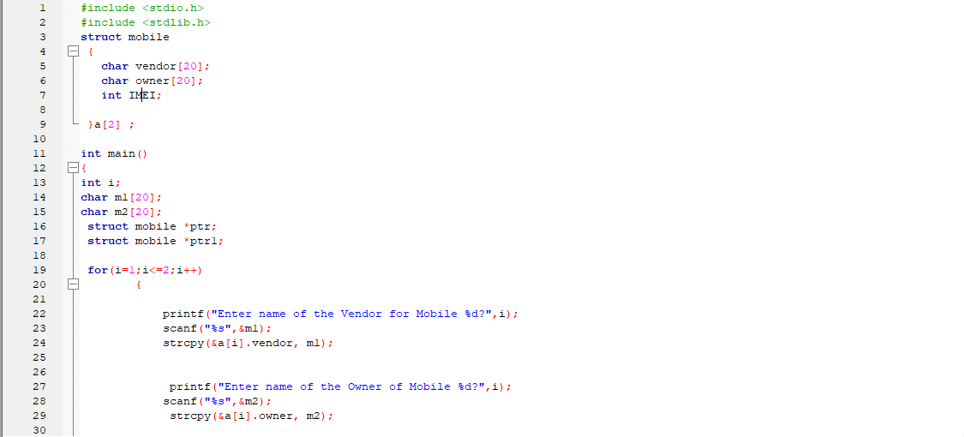

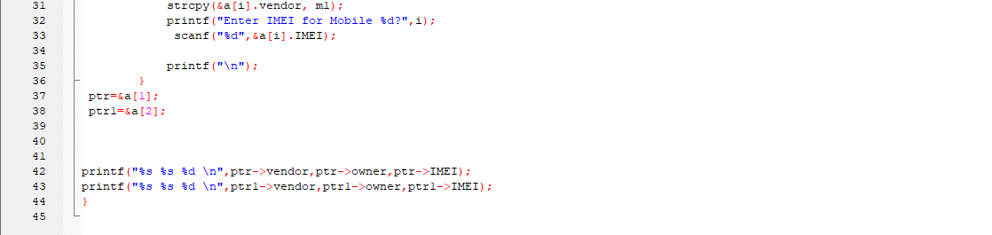

The Result of the following code is attached below:

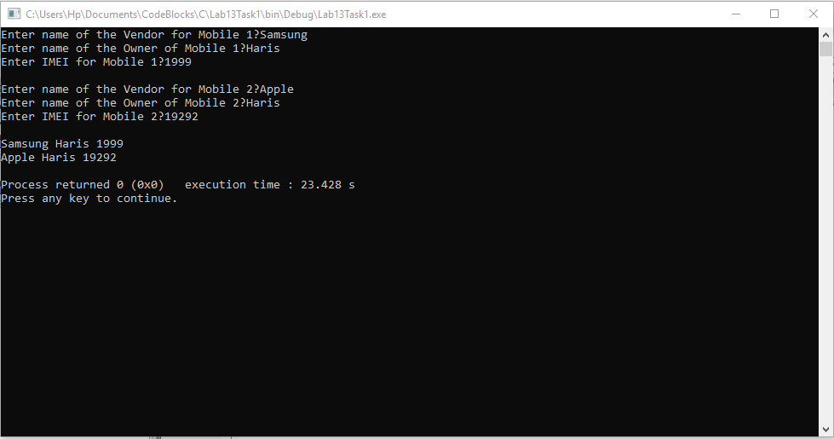

-------------------------------

**Question no: 2(A)**

Write a C program that has structure called person. Instance of that structure should contain name, weight and age of that person. Program should take number of persons. Then use dynamic memory allocation to have that memory for record. User should enter the minimum specified number of records. And print these records.

Solution

The code is shown below for the given program,

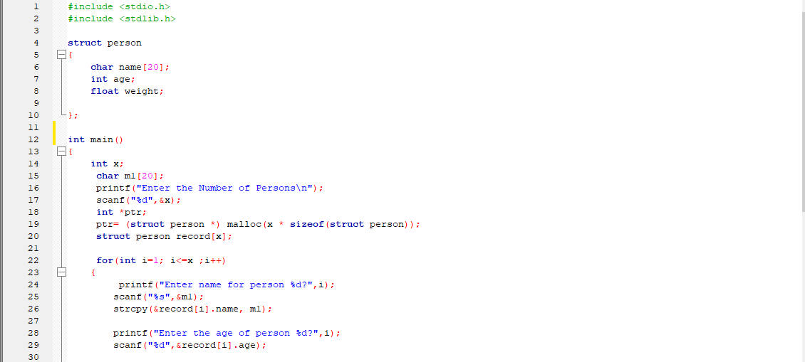

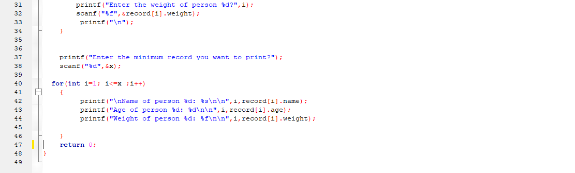

The Result of the following code is attached below:

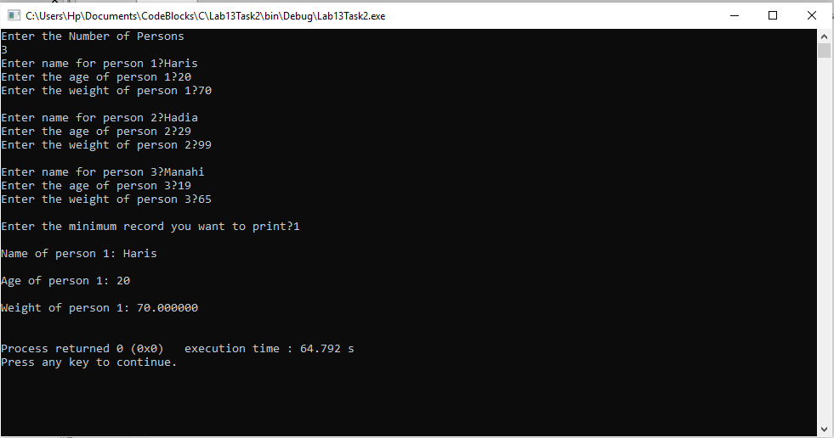

------------------------------

THE END

*there was no post lab for this lab.